COMPARATIVE TRANSCRIPTOMIC ANALYSIS OF MULTIPLE SCLEROSIS
1. OBJECTIVE
To identify robust differentially expressed genes (DEGs) associated with Multiple Sclerosis by integrating multiple publicly available transcriptomics datasets, followed by functional enrichment analysis, protein-protein interaction (PPI) network construction, hub gene identification and biomarker prioritization.
2.METHODOLOGY
2.1 Workplan
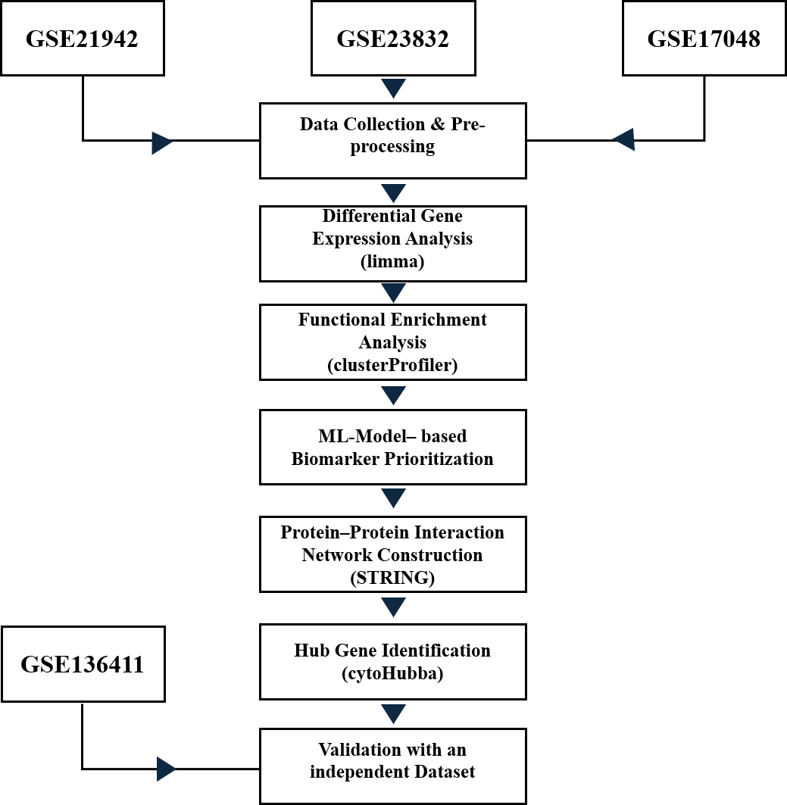
Fig 1 Workflow

2.2 Data Collection
From the NCBI GEO database, datasets were searched using “multiple sclerosis” query and filtered the species. The following datasets were found suitable for the analysis. The dataset name, type of data, the annotation id, number of samples (healthy and MS), and purpose of analysis is detailed in the table below.
Dataset | Type | Annotation ID | Number of Samples (Healthy) | Number of Samples (MS) | Purpose of Analysis
GSE21942 | Expression profiling by array | GPL570[HG-U133_Plus_2] Affymetrix Human Genome U133 Plus 2.0 Array | 15 | 12 | Discovery Dataset
GSE23832 | Expression profiling by array | GPL6244[HuGene-1_0-st] Affymetrix Human Gene 1.0 ST Array [transcript (gene) version] | 4 | 8 | Discovery Dataset
GSE17048 | Expression profiling by array | GPL6947 Illumina HumanHT-12 V3.0 expression beadchip | 45 | 36(RRMS) | Discovery Dataset
GSE136411 | Expression profiling by array | GPL6104 Illumina humanRef-8 v2.0 expression beadchip  GPL10558 Illumina HumanHT-12 V4.0 expression beadchip | 67 | 60(CIS)  121(RRMS) | Validation Dataset
Table 1. Summary of the GEO Datasets and description
2.3 Data Processing
Gene Expression datasets GSE21942 and GSE17048 were downloaded from the NCBI Gene Expression Omnibus (GEO) database and analyzer using R software. Gene expression matrices, platform annotation files were obtained using the GEOQuery package. Probe identifiers were mapped to the Gene symbols using the corresponding annotation files. The duplicate probes were removed where the multiple probes represented the same gene, and retained the single representative probe.
The GSE23832 dataset was analyzed using the online GEO2R tool, because the processed differential expression results were readily available. DEGs from GSE21942, GSE17048 were identified using the limma package. Linear models were fit to each gene followed by the eBayes moderation to improve variance estimation.
Genes with P value ≤ 0.05 were considered significantly differentially expressed. Significant DEGs were obtained from the three discovery datasets, and were merged together. After removing the duplicate gene symbols, a combined total of 898 unique DEGs were listed out. Based on the logFC, the merged DEGs were ranked and the top 100 upregulated and downregulated genes were selected for downstream analysis
2.4 Functional Enrichment Analysis
To investigate the biological significance of the identified DEGs, Gene Ontology (GO) Biological Process enrichment analysis and Kyoto Encyclopedia of Genes and Genomes (KEGG) pathway enrichment analysis was performed separately for upregulated and downregulated gene sets using clusterProfiler package in R. Gene symbols were converted to Entrez Gene IDs prior to enrichment analysis. Enriched GO terms and KEGG pathways with a P-value ≤ 0.05 were considered statistically significant. Dot plots were generated to visualize the significantly enriched biological processes and pathways.
2.5 Protein–Protein Interaction Network Construction and Hub Gene Identification
Protein–protein interaction (PPI) networks were constructed using the STRING database (version 12.0) with Homo sapiens selected as the reference organism. Significant interaction networks were exported into Cytoscape (version 3.10 or later) for visualization and network analysis.
Hub genes were identified using the cytoHubba plugin in Cytoscape based on network topology. The highest-ranking genes with the greatest network connectivity were selected as potential hub genes involved in Multiple Sclerosis pathogenesis.
2.6 Machine Learning Approach
To prioritize potential biomarker genes, several machine learning regression algorithms including Linear Regression, Decision Tree Regressor, Random Forest Regressor, Gradient Boosting Regressor, Support Vector Regressor (SVR), and K-Nearest Neighbour (KNN) Regressor were evaluated using the merged significant DEG dataset. Model performance was assessed using the coefficient of determination (R²) and Mean Squared Error (MSE).
Among the evaluated models, the Random Forest Regressor demonstrated superior predictive performance and was therefore selected for biomarker prioritization. The trained model generated an importance score for each gene, allowing genes to be ranked according to their contribution to the predictive model. The top 100 upregulated and top 100 downregulated genes identified through machine learning were compared with those obtained from the statistical differential expression analysis to generate the final list of candidate biomarker genes.
2.7 Candidate Genes
Followed by the comparison with the Machine Learning model, the final list of candidate 100 upregulated and downregulated genes was generated.
2.8 Validation Using an Independent Dataset
To validate the identified candidate biomarkers, an independent Multiple Sclerosis transcriptomic dataset (GSE136411) was analyzed following the same differential expression analysis strategy. Significant DEGs were identified using a P-value threshold of ≤ 0.05, and the resulting upregulated and downregulated genes were compared with the candidate genes obtained from both the statistical and machine learning approaches. Genes consistently identified across discovery and validation datasets were considered robust candidate biomarkers for Multiple Sclerosis.
3 RESULTS
3.1 Identification of Significant Differentially Expressed Genes
Differential Expression Analysis was performed on the three publicly available transcriptomic datasets, (GSE17048, GSE21942, and GSE23832). Significant genes were identified using a P-value threshold of ≤ 0.05. The significant DEGs from all three datasets were integrated to generate a merged dataset comprising 898 significant differentially expressed genes. Based on the log fold change (logFC), the merged DEGs were classified into upregulated and downregulated gene sets for subsequent analyses.
The top 100 upregulated and top 100 downregulated genes were selected based on logFC for functional enrichment analysis and biomarker prioritization.

3.2 GO and Biological Process Enrichment Analysis
GO Biological Process enrichment analysis was performed separately for the upregulated and downregulated gene sets.
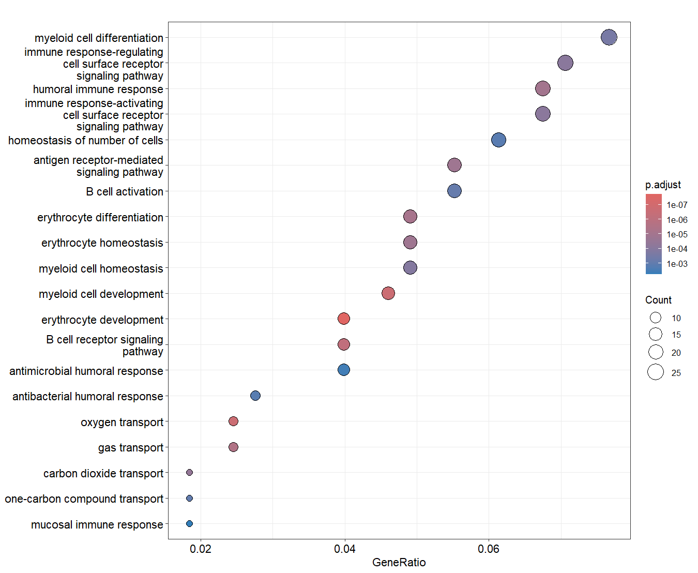
Fig 2 GO analysis of Upregulated Genes
Gene Ontology (GO) analysis (Fig 2) revealed the significant enrichment of immune related biological processes indicating extensive activation of both innate and adaptive immune responses in Multiple Sclerosis.
The most significantly enriched GO terms included myeloid cell differentiation, immune response regulating, cell surface receptor signalling pathway, humoral immune response, immune-response activating, B-cell activation. Several processes associated with Myeloid cell homeostasis and erythrocyte differentiation were also enriched.
The enrichment of antigen receptor signalling and B-cell activation pathways suggest increased adaptive immune activity, whereas myeloid cell differentiation and immune receptor signalling indicates activation of innate immune cells. Together, these findings support the involvement of coordinated immune dysregulation in the pathogenesis of Multiple Sclerosis
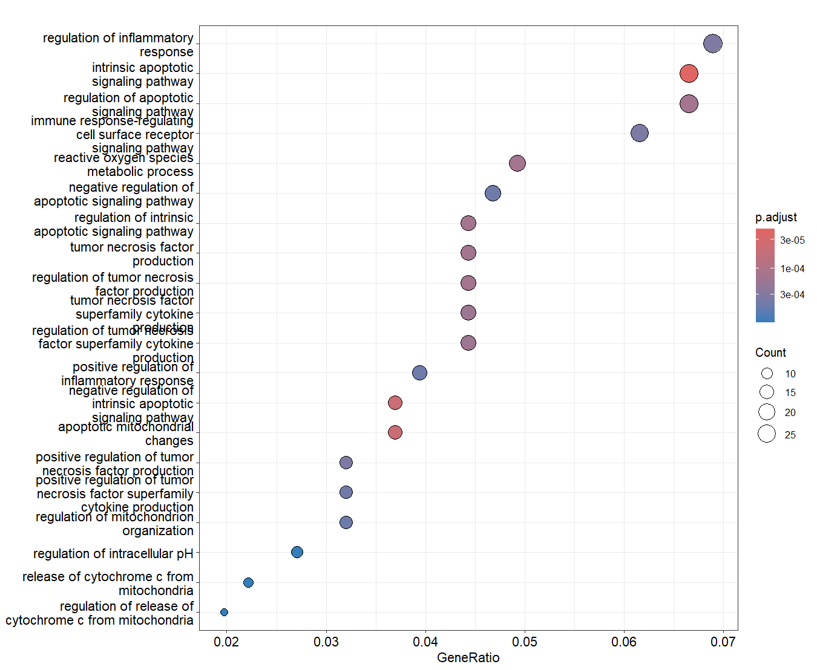
Fig 3 GO analysis of downregulated genes
Gene Ontology (GO) Biological Process enrichment analysis of the top 100 downregulated genes revealed significant enrichment of biological processes associated with inflammatory regulation, apoptotic signaling, cytokine production, and immune receptor-mediated signaling. The most significantly enriched GO terms included regulation of inflammatory response, intrinsic apoptotic signaling pathway, regulation of apoptotic signaling pathway, immune response-regulating cell surface receptor signaling pathway, and reactive oxygen species metabolic process.
Several cytokine-related processes, including tumor necrosis factor (TNF) production, positive regulation of inflammatory response, and positive regulation of TNF superfamily cytokine production, were also significantly enriched among the downregulated genes. Additionally, biological processes related to release of cytochrome c from mitochondria, regulation of intracellular pH, and reactive oxygen species metabolism were enriched, suggesting alterations in mitochondrial function and apoptosis-related pathways.
These findings indicate that genes involved in immune regulation, inflammatory signaling, apoptosis, and oxidative stress responses are downregulated in Multiple Sclerosis, suggesting disruption of normal immune homeostasis and cellular stress-response mechanisms.

3.3 KEGG Pathway analysis
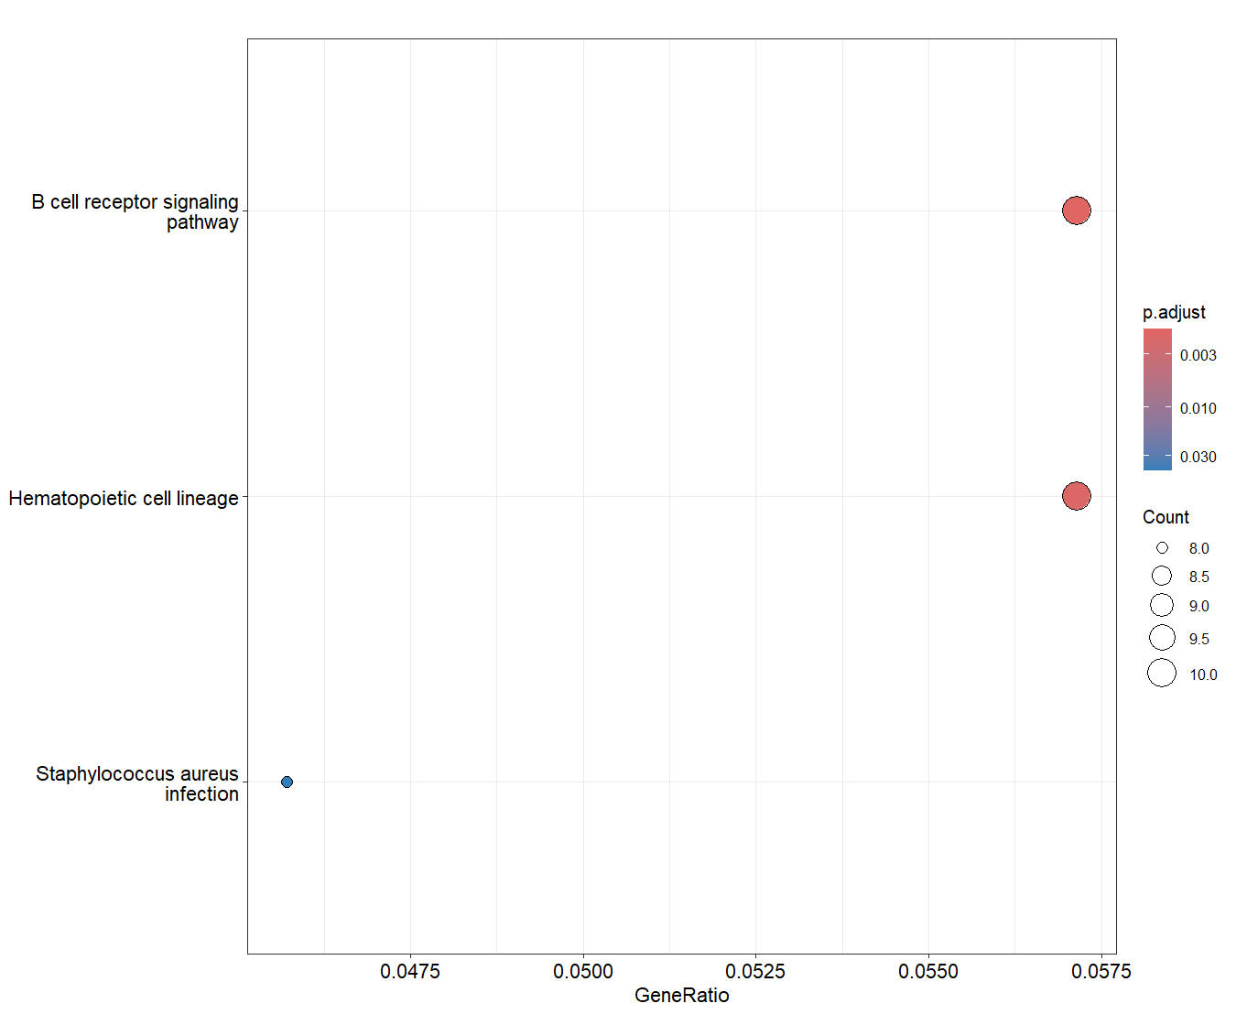
Fig 4 KEGG pathway enrichment of upregulated genes
KEGG pathway analysis of the top 100 upregulated genes identified three significantly enriched pathways, B-cell receptor signalling pathway, Haematopoetic cell lineage pathway, and S.aureus infection.
The enrichment of B-cell signalling pathway suggests the enhanced activation of B-cell-mediated immune responses, consistent with the established role of B-lymphocytes in the pathogenesis of Multiple Sclerosis.
Enrichment of the Hematopoietic cell lineage pathway indicates altered regulation of immune cell development and differentiation. The enrichment of the Staphylococcus aureus infection pathway reflects the involvement of genes associated with host immune defense mechanisms rather than the presence of bacterial infection, as many immune-related genes are shared across infectious disease pathways.
Overall, these findings indicate that the upregulated genes are predominantly involved in adaptive immune responses and immune cell differentiation, supporting the contribution of immune dysregulation to Multiple Sclerosis.
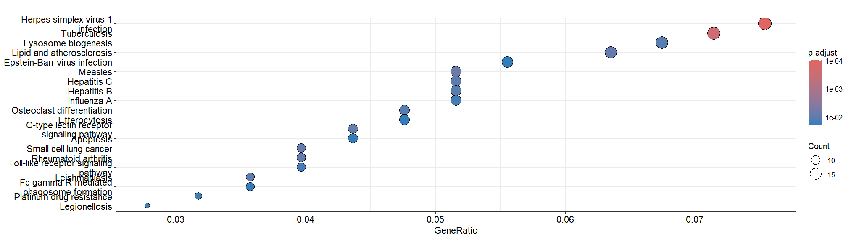
Fig 5 KEGG pathway enrichment of downregulated genes
KEGG pathway enrichment analysis of the top 100 downregulated genes identified multiple significantly enriched pathways, the majority of which were associated with immune responses, host defense, and infectious diseases. The most significantly enriched pathways included Herpes simplex virus 1 infection, Tuberculosis, Lysosome, Epstein–Barr virus infection, Influenza A, Hepatitis B, and Hepatitis C (Fig5).
In addition, several immune-related signaling pathways, including C-type lectin receptor signaling pathway, Toll-like receptor signaling pathway, Fc gamma R-mediated phagocytosis, and Osteoclast differentiation, were significantly enriched. Pathways related to Apoptosis, Efferocytosis, and Rheumatoid arthritis were also enriched among the downregulated genes.
Overall, these findings indicate that genes involved in innate immune signaling, pathogen recognition, inflammatory responses, phagocytosis, and apoptosis are significantly downregulated in Multiple Sclerosis, suggesting altered regulation of host immune defense and inflammatory pathways.
3.4 PPI Network & Hub Gene Identification

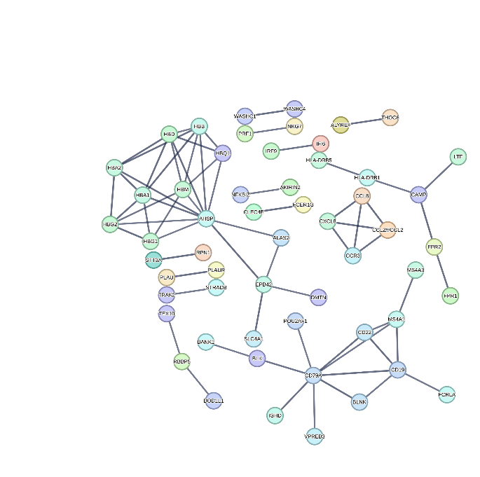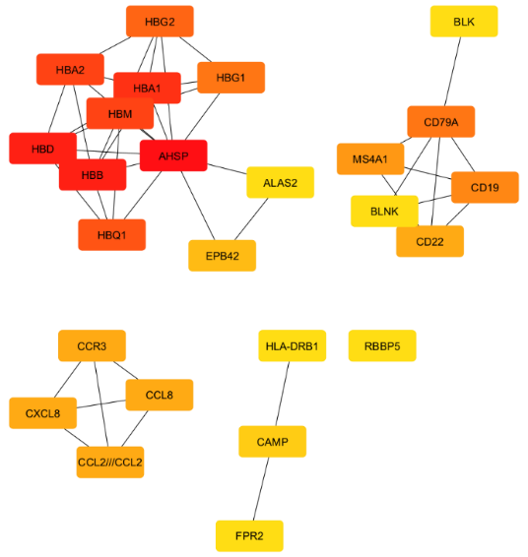
Fig 6(a) Protein–Protein Interaction (PPI) Network Fig 6(b) Hub Gene Network
To investigate the functional interactions among the candidate differentially expressed genes, a protein–protein interaction (PPI) network was constructed using the STRING database and visualized in Cytoscape. The resulting network demonstrated multiple highly interconnected clusters, indicating coordinated interactions among genes involved in immune regulation, erythrocyte function, inflammatory signaling, and B-cell-mediated immune responses.
Several distinct functional modules were observed within the network. A prominent cluster consisted of hemoglobin-associated genes including HBA1, HBA2, HBB, HBD, HBG1, HBG2, HBM, and AHSP, suggesting coordinated regulation of erythroid-associated biological processes. Another major cluster comprised B-cell-related genes, including CD19, CD22, CD79A, BLK, BLNK, and MS4A1, indicating enrichment of adaptive immune signaling pathways. Additional interaction modules containing CXCL8, CCL8, CCR3, CAMP, FPR2, and HLA-DRB1 were associated with inflammatory responses, leukocyte chemotaxis, and innate immune activation (Fig 6 (a)).
Overall, the PPI network demonstrated that the identified candidate genes form biologically interconnected modules involved in immune regulation and inflammatory processes relevant to Multiple Sclerosis.
Hub gene analysis was performed using the cytoHubba plugin in Cytoscape to identify highly connected genes within the PPI network. The analysis identified several hub genes with high network connectivity, including HBA1, HBA2, HBB, HBD, HBG1, HBG2, HBM, AHSP, BLK, CD19, CD22, CD79A, BLNK, MS4A1, CXCL8, CCL8, CCR3, CAMP, FPR2, and HLA-DRB1 (Fig 6(b))
These hub genes represent key molecular components involved in immune regulation, antigen presentation, B-cell activation, inflammatory signaling, and host defense. Their central positions within the interaction network suggest that they may play important roles in the molecular mechanisms underlying Multiple Sclerosis and therefore represent potential biomarker candidates for further investigation.
3.5 Machine Learning-Based Gene Prioritization
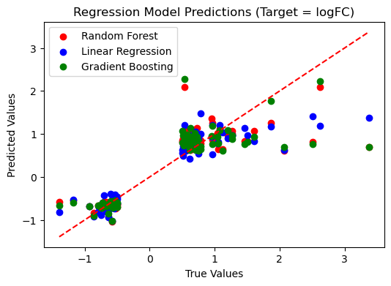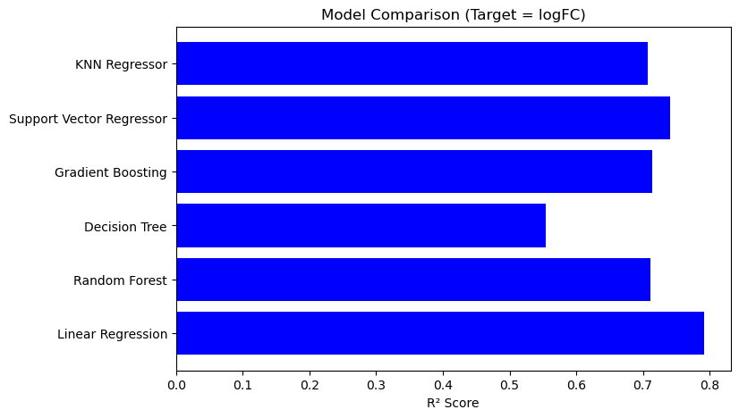
Fig7(a) Fig 7(b)
Fig 7(a) Comparison of predicted and observed logFC values generated by the Random Forest, Linear Regression, and Gradient Boosting models. The dashed red line represents the line of perfect agreement between predicted and observed values. Fig 7(b) Comparison of regression model performance for prediction of log fold-change (logFC). Model performance was evaluated using the coefficient of determination (R²). Linear Regression achieved the highest predictive performance, followed by Support Vector Regression, Gradient Boosting, Random Forest, K-Nearest Neighbour, and Decision Tree Regression.
To prioritize potential biomarker genes, six regression-based machine learning algorithms, including Linear Regression, Random Forest Regressor, Decision Tree Regressor, Gradient Boosting Regressor, Support Vector Regressor (SVR), and K-Nearest Neighbour (KNN) Regressor, were evaluated using the merged significant DEG dataset.
Model performance was assessed using the coefficient of determination (R²) and prediction accuracy. Among the evaluated models, Linear Regression achieved the highest predictive performance (R² ≈ 0.79), followed by Support Vector Regressor (R² ≈ 0.74), Gradient Boosting Regressor (R² ≈ 0.71), Random Forest Regressor (R² ≈ 0.70), KNN Regressor (R² ≈ 0.69), and Decision Tree Regressor (R² ≈ 0.55) (Figure 7(b)).
Although Linear Regression demonstrated the highest overall predictive performance, the Random Forest Regressor was selected for gene prioritization because of its ability to capture non-linear relationships and rank genes according to their relative importance. The scatter plot comparing predicted and observed log fold-change values demonstrated that the Random Forest model produced predictions that closely followed the observed expression values, indicating satisfactory predictive performance.
The Random Forest model identified several highly ranked genes, including AHSP, HBA1, HBA2, HBB, HBG1, HBG2, HBM, CD19, CD22, CD79A, MS4A1, BLK, and FCRLA. Many of these genes were also identified as hub genes in the protein–protein interaction network, supporting their potential importance in Multiple Sclerosis pathogenesis.
Overall, the machine learning approach complemented the differential expression and network analyses by prioritizing candidate biomarkers with high predictive relevance and biological significance.
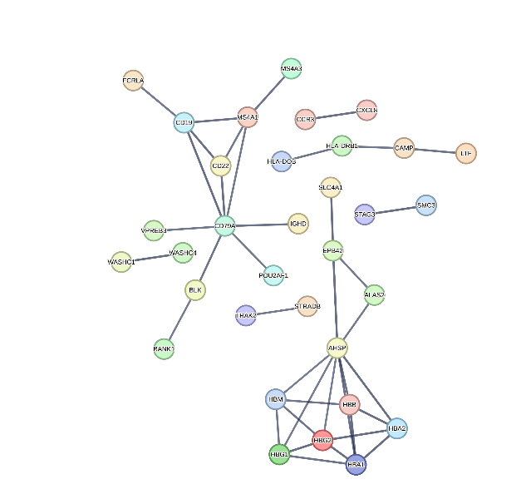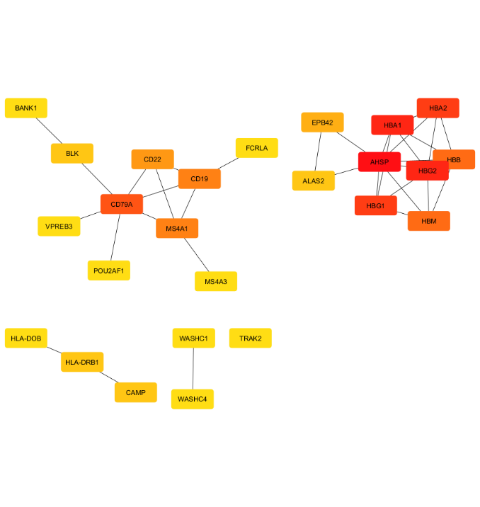
Fig 8(a) Protein–Protein Interaction (PPI) Network Fig 8(b) Hub Gene Network
Following machine learning-based gene prioritization, the top-ranked genes identified by the Random Forest model were subjected to protein–protein interaction analysis using the STRING database. The resulting network revealed several interconnected modules associated with immune regulation, B-cell activation, erythrocyte biology, and antigen presentation.
A prominent interaction cluster consisted of CD19, CD22, CD79A, MS4A1, BLK, FCRLA, and VPREB3, representing genes involved in B-cell receptor signaling and adaptive immune responses. Another highly connected cluster comprised AHSP, HBA1, HBA2, HBB, HBG1, HBG2, and HBM, reflecting coordinated erythroid-associated biological processes. Additional interaction modules included HLA-DRB1, HLA-DQB, CAMP, CXCL8, and CCR3, which are associated with antigen presentation and inflammatory responses (Fig 8(a)).

Overall, the machine learning-prioritized genes formed biologically relevant interaction networks that support their potential functional importance in Multiple Sclerosis. Hub gene analysis of the machine learning-prioritized PPI network was performed using the cytoHubba plugin in Cytoscape. The analysis identified several highly connected genes, including AHSP, HBA1, HBA2, HBB, HBG1, HBG2, HBM, CD19, CD22, CD79A, MS4A1, BLK, FCRLA, VPREB3, BANK1, HLA-DRB1, HLA-DQB, CAMP, and ALAS2 (Fig8(b))
Many of these genes overlapped with the hub genes identified from the conventional differential expression analysis, while additional genes such as BANK1, FCRLA, VPREB3, POU2AF1, and WASHC4 were uniquely prioritized by the machine learning approach. These findings suggest that integrating machine learning with network analysis improves biomarker prioritization by identifying genes with both strong predictive performance and high biological connectivity.
3.9 Validation of Candidate Biomarkers Using Machine Learning and an Independent Dataset
To assess the robustness of the identified candidate biomarkers, the final list of genes obtained from the conventional differential expression analysis was compared with the genes prioritized by the Random Forest machine learning model and with an independent validation dataset (GSE136411).
Comparison with the machine learning-prioritized genes demonstrated substantial overlap between the two approaches, indicating that several candidate biomarkers were consistently identified using both statistical and machine learning-based analyses. This agreement supports the reliability of the selected biomarkers and highlights genes that are likely to play important roles in Multiple Sclerosis.
Further validation was performed using the independent transcriptomic dataset GSE136411. Comparison of the final candidate gene list with the significant differentially expressed genes identified in the validation dataset revealed 11 commonly upregulated genes and one commonly downregulated gene. The consistent differential expression of these genes across independent datasets and analytical approaches suggests that they represent robust candidate biomarkers associated with Multiple Sclerosis.
Overall, the integration of differential expression analysis, machine learning-based prioritization, and independent dataset validation increased confidence in the identified biomarkers and reduced the likelihood that the observed findings were dataset-specific.
Table 2 summarizes the candidate biomarkers that were consistently identified through differential expression analysis, machine learning-based prioritization, and validation using the independent dataset.
Gene | Regulation | Present in DEG Analysis | ML Prioritization | Independent Dataset
HBD | Up | ✓ | ✓ | ✓
DEFA1 | Up | ✓ | ✓ | ✓
CLC | Up | ✓ | ✓ | ✓
EPB42 | Up | ✓ | ✓ | ✓
AHSP | Up | ✓ | ✓ | ✓
HDC | Up | ✓ | ✓ | ✓
CD69 | Up | ✓ | ✓ | ✓
NR4A2 | Up | ✓ | ✓ | ✓
CAMP | Up | ✓ | ✓ | ✓
PER1 | Up | ✓ | ✓ | ✓
DUSP2 | Up | ✓ | - | ✓
CCL8 | Down | ✓ | - | ✓
Table 2 Validation of Candidate Biomarkers Using Machine Learning and an Independent Dataset

